LAB SESSION 3

By Harsh R Jain 1BG17CS031

Sample Program:

<html>

<head>

<script>

function dis(val)

{

document.getElementById("result").value+=val

}

function solve()

{

let x = document.getElementById("result").value

let y = eval(x)

document.getElementById("result").value = y

}

function clr()

{

document.getElementById("result").value = ""

}

</script>

<!-- for styling -->

<style>

input[type="button"]

{

background-color:white;

color: black;

border: solid black 1px;

width:100%;

border-radius: 50%;

}

input[type="text"]

{

background-color:white;

border: solid black 1px;

width:100%;

padding:10px

}

input[type="button"]:hover

{

background-color:red;

}

table{

border-collapse: collapse;

border:1px;

}

table tr{

height: 30px;

}

</style>

</head>

<!-- create table -->

<body>

<table border='2'>

<tr>

<td colspan="4"><input type="text" height="100px" id="result"/></td>

<!-- clr() function will call clr to clear all value -->

</tr>

<tr>

<!-- create button and assign value to each button -->

<!-- dis("1") will call function dis to display value -->

<td><input type="button" value="1" onclick="dis('1')"/> </td>

<td><input type="button" value="2" onclick="dis('2')"/> </td>

<td><input type="button" value="3" onclick="dis('3')"/> </td>

<td><input type="button" value="/" onclick="dis('/')"/> </td>

</tr>

<tr>

<td><input type="button" value="4" onclick="dis('4')"/> </td>

<td><input type="button" value="5" onclick="dis('5')"/> </td>

<td><input type="button" value="6" onclick="dis('6')"/> </td>

<td><input type="button" value="-" onclick="dis('-')"/> </td>

</tr>

<tr>

<td><input type="button" value="7" onclick="dis('7')"/> </td>

<td><input type="button" value="8" onclick="dis('8')"/> </td>

<td><input type="button" value="9" onclick="dis('9')"/> </td>

<td><input type="button" value="+" onclick="dis('+')"/> </td>

</tr>

<tr>

<td><input type="button" value="c" onclick="clr()"/> </td>

<td><input type="button" value="0" onclick="dis('0')"/> </td>

<td><input type="button" value="=" onclick="solve()"/> </td>

<td><input type="button" value="*" onclick="dis('*')"/> </td>

</tr>

</table>

</body>

</html>

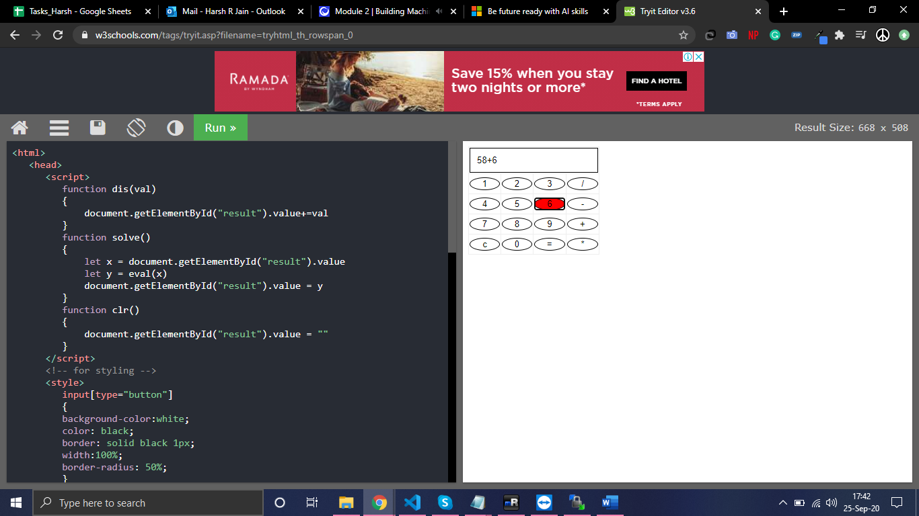

Program 1:

<!DOCTYPE

HTML> <html>

<head>

<style>

table, td, th

{

border: 1px solid black;

width: 33%;

text-align: center;

background-color: DarkGray;

border-collapse:collapse;

}

table { margin: auto; }

input { text-align:right; }

</style>

<script type="text/javascript">

function calc(clicked_id)

{

Var val1 =

parseFloat(document.getElementById("value1").value);

var val2 =

parseFloat(document.getElementById("value2").value);

if(isNaN(val1)||isNaN(val2))

alert("ENTER VALID NUMBER");

else if(clicked_id=="add")

document.getElementById("answer").value=val1+val

2;

else if(clicked_id=="sub")

document.getElementById("answer").value=val1-

val2;

else if(clicked_id=="mul")

document.getElementById("answer").value=val1*val2;

else if(clicked_id=="div")

document.getElementById("answer").value=val1/val2;

}

function cls()

{

value1.value="0";

value2.value="0";

answer.value="";

}

</script>

</head>

<body>

<table>

<tr><th colspan="4"> SIMPLE CALCULATOR </th></tr>

<tr><td>value1</td><td><input type="text" id="value1"

value="0"/></td> <td>value2</td><td><input type="text" id="value2"

value="0"/> </td></tr> <tr><td><input type="button" value="Addition"

id = "add" onclick="calc(this.id)"/></td>

<td><input type="button" value="Subtraction" id = "sub"

onclick="calc(this.id)"/></td>

<td><input type="button" value="Multiplication" id = "mul"

Web Technology Lab With Mini Project – 15CSL77 2018-2019

Dept. of CSE, MSEC Page 6

onclick="calc(this.id)"/></td>

<td><input type="button" value="Division" id ="div"

onclick="calc(this.id)"/></td></tr>

<tr><td>Answer:</td><td> <input type="text" id="answer" value=""

disabled/></td>

<td colspan="2"><input type="button" value="CLEAR ALL"

onclick="cls()"/></td> </tr>

</table>

</body>

</html>

